**Milestone III submission**

**Team: The Next Team**

**Proposed Level of Achievement:** Gemini

You can try out the game here: <https://play.google.com/store/apps/details?id=com.TheNextTeam.BusDriver>

Notes: This beta version is only to serve the trying and grading of the project without any further commercialization purpose, which will be taken down if there are any requirements from orbitals.

**Features in the Game:**

* User interface: menu, shop, main gameplay, sound effect and setting
* Different quests to play
* Collecting coins and items
* Personalization of bus
* Buying items
* Social media sharing
* Leaderboard and achievements

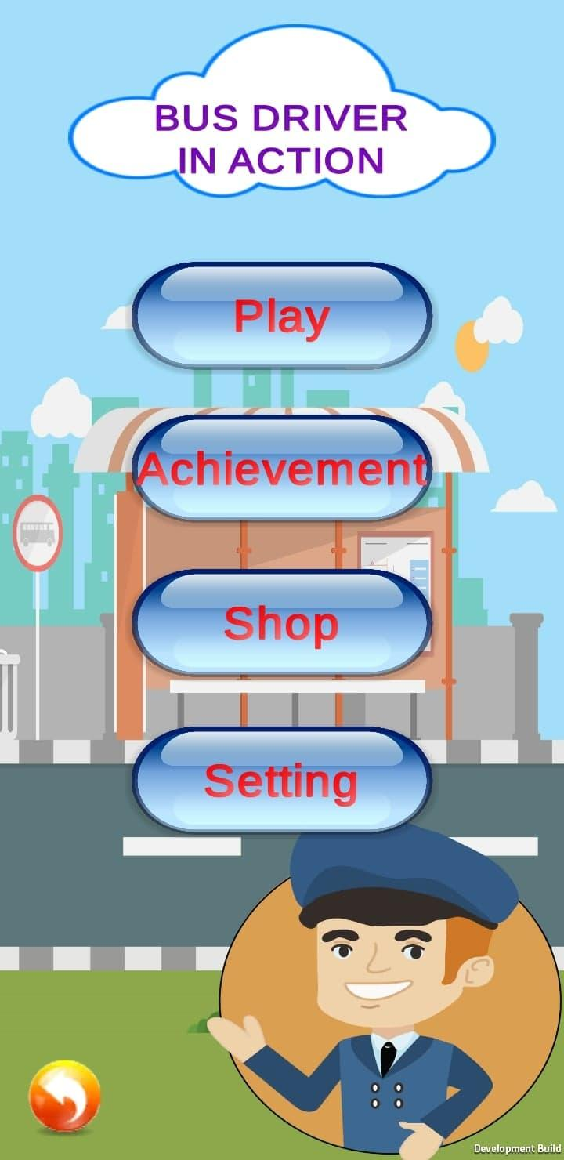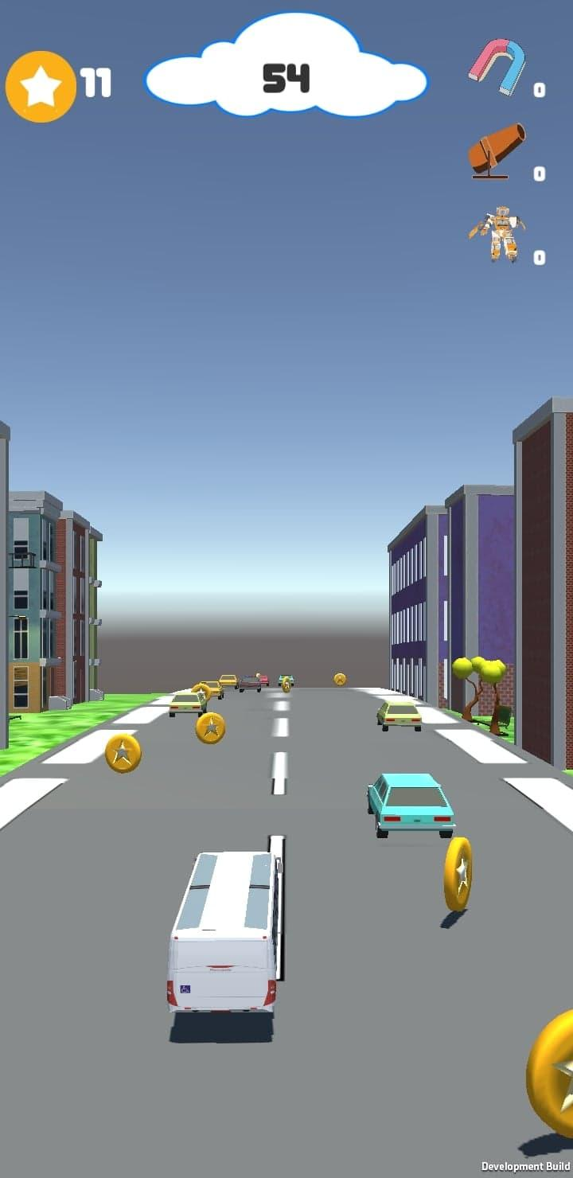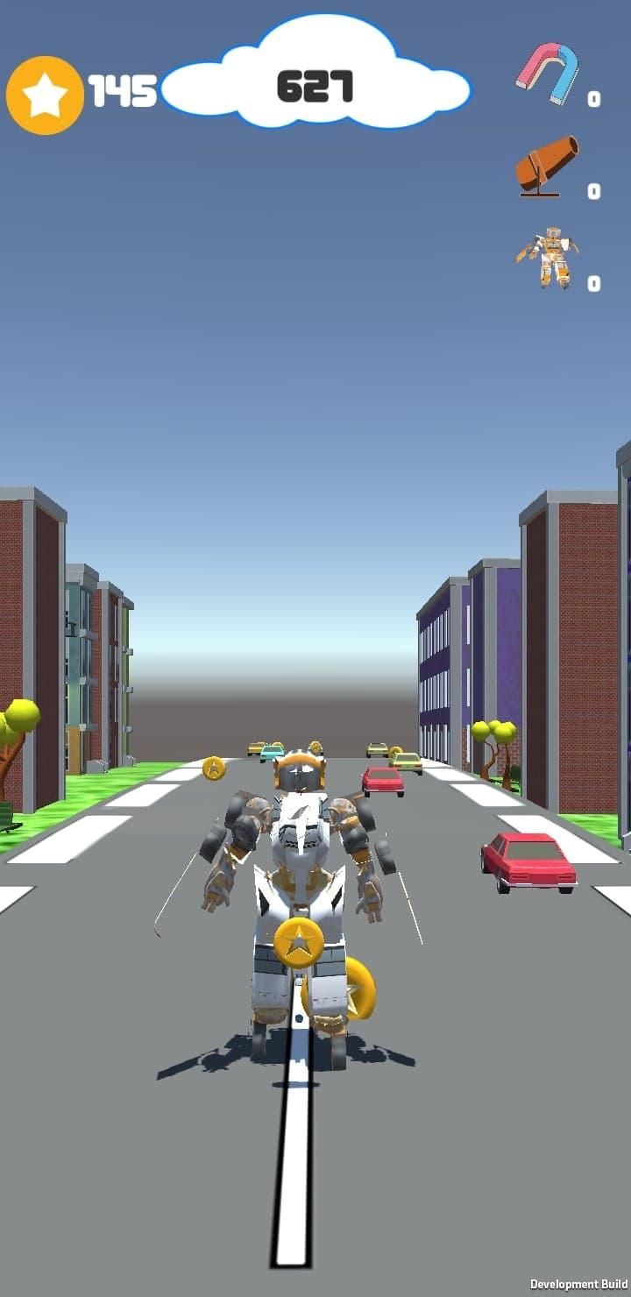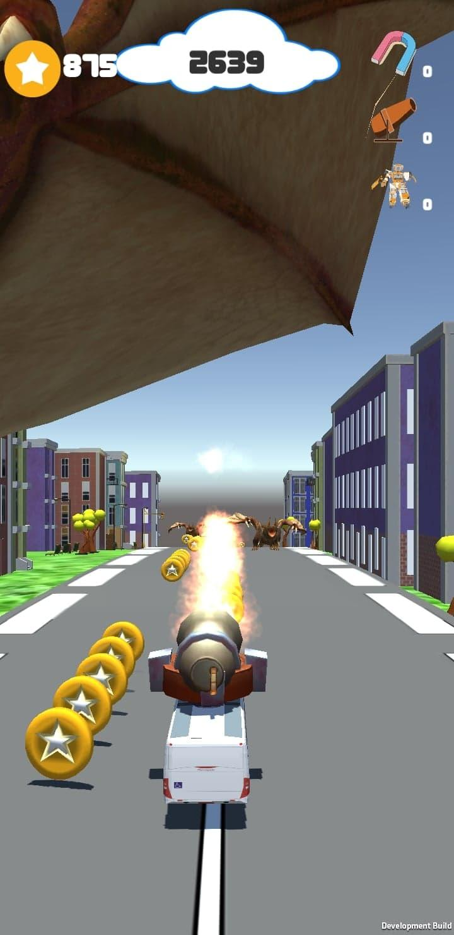

**Developments from MileStone II:**

* Finishing all the game logic for single player mode (including moving, collecting coins, items effects)
* Storing and showing best scores locally, storing coins for future shop developments
* Adding advertisements for option to revive the games
* Making a share system for sharing through social media platform (Facebook)

**Developments in MileStone III:**

* Successfully completing user login authentication and fully creating workable achievements board and leaderboard.
* Creating a shop system which involves player personalization, item shopping to support playing, all involving different levels of users’ achievement in the game.



* Updating game logics.
* Fixing bugs found by user involved testing.

**Back-end Progress:**

* Making a database to store user’s scores, achievements and leaderboard using Google play cloud.

**Testing involving users:**

Since our game targets at casual users, we involve our alpha testing for a group of users with a range of ages, professions and genders. Even though there are still potential bias as our alpha users are only individuals in our social network, we try our best to perform improvements in users’ use by:

* Collecting information about how they want to personalize their player, which is the bus. However, it was surprising that as alpha testers feel it could be irritating if the bus having too many things on it (blocking sights, not logical, etc.). Hence, we decided changing the bus color should be a reasonable choice.

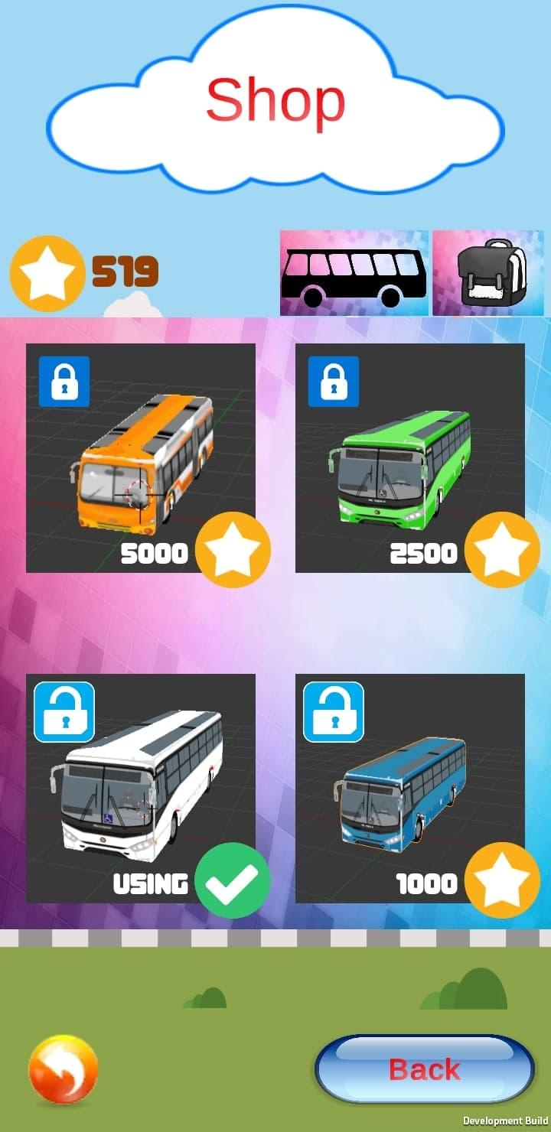

* Collecting feedbacks on the game logic, users’ experiences and bug reports. It was an essential steps as we discovered several bugs and problematic logic that we were uninformed, such as the spawning item frequency, inconvenient shoot button, and unsaved bus settings. We have fixed the mentioned issues.
* Updating shop based on users’ achievements. From other teams’ feedbacks in milestone 2, it came to us that users can get bored soon and we needed some incentives or challenges for users.



Lock, unlock system: As when user buy a bus, the next one will be unlock

**Problems encountered:**

* Login problem from milestone 2 has been fixed.
* Sharing through Facebook cannot show scores and messages, it requires a public personal website, which is out of the scope of this project.